**14/3/25 AEM FINAL ASSIGNMENT**

**SCREENSHOTS**

**🎃 Welcome to the Portfolio of Stephen King! 🖋️🔪**

***"Step into the eerie world of Stephen King, the master of horror, suspense, and the supernatural. Explore his iconic novels, spine-chilling short stories, and the dark imagination that has captivated millions worldwide"* 👁️📖🔥**

**Header & Footer**

The header and footer provide a structured layout, ensuring smooth navigation across different sections of the website.

***HEADER***

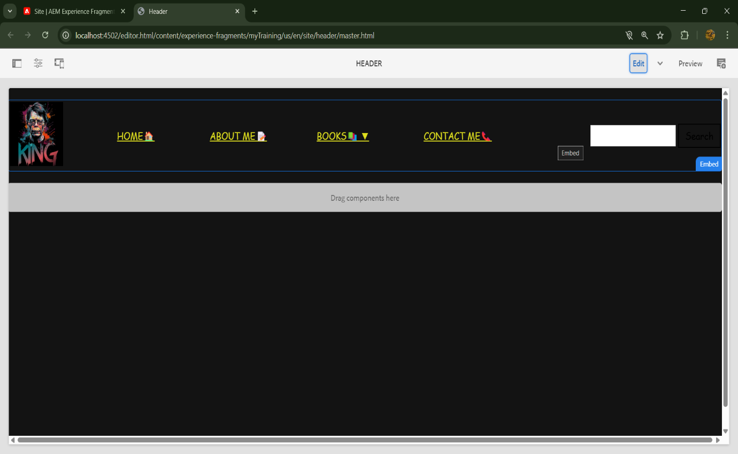

***FOOTER***

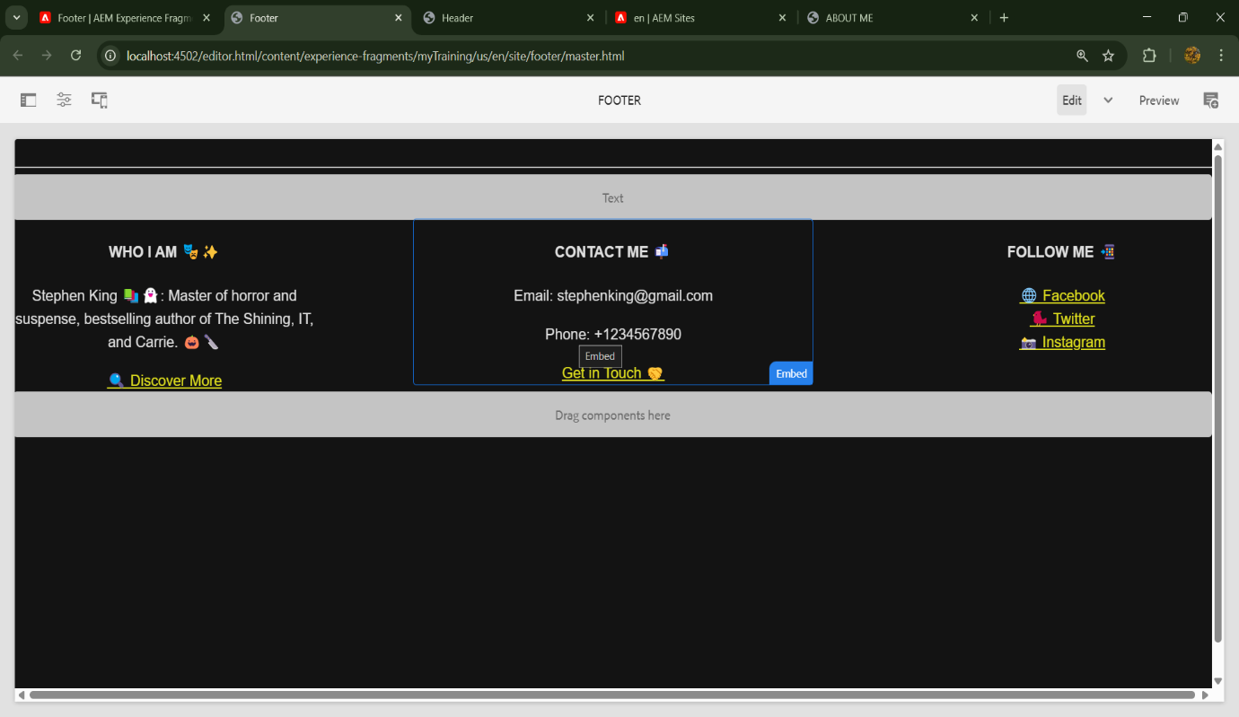

**🎨 Styled Header & Footer**

After applying styling, the header and footer now have a more polished,aesthetic, matching the dark ambiance of Stephen King's work.

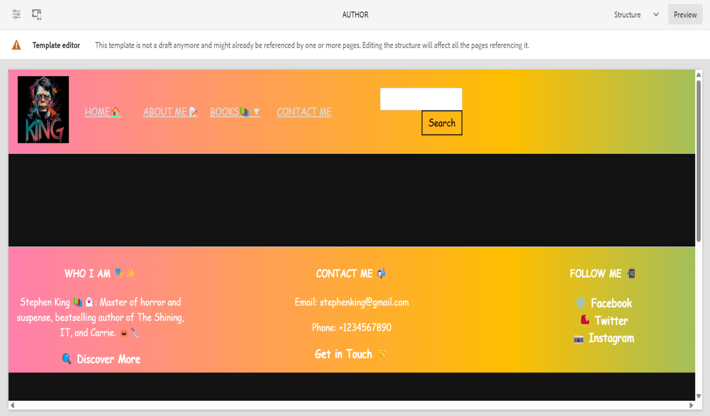

***PAGE STRUCTURE***

Created Navigation Pages using Content Page

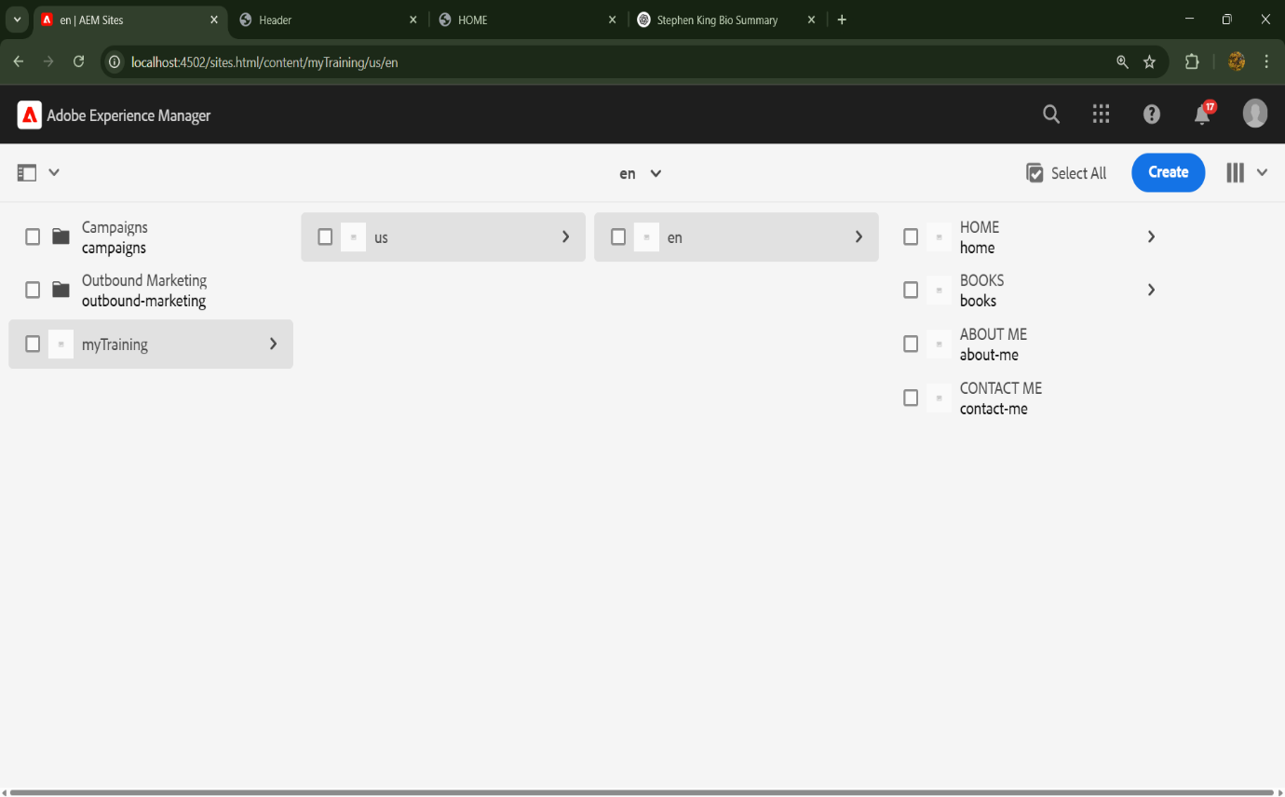

***TEMPLATE*** *CREATION*

Created a template **author** and used it for various page creations

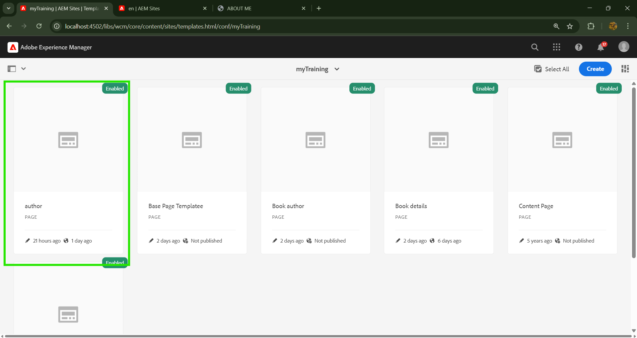

***AWARD PAGES CREATED USING TEMPLATE***

A dedicated section highlighting **Stephen King's prestigious awards**, along with details of the books that earned them.

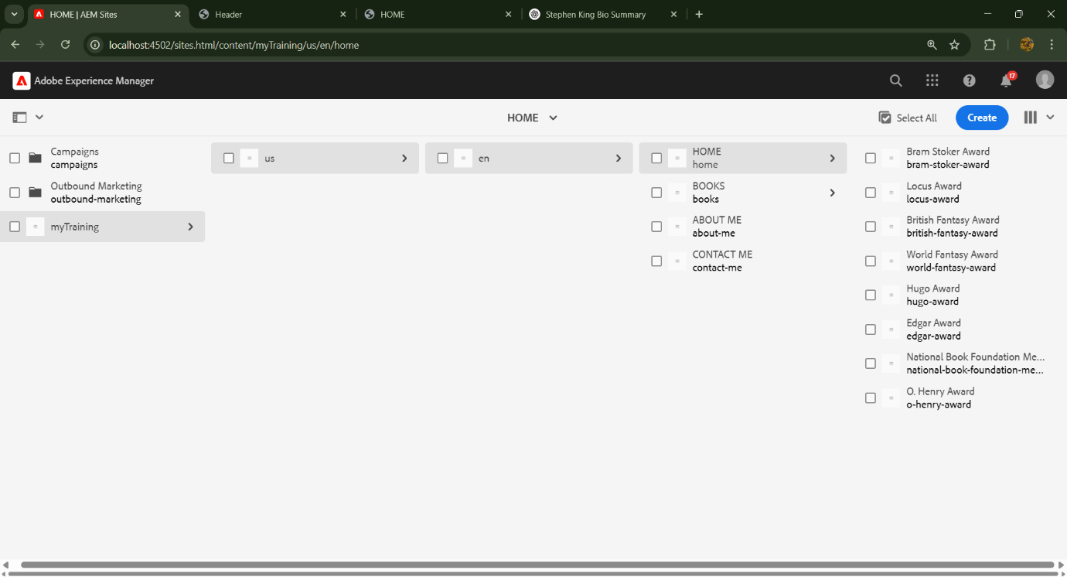

***BOOK PAGES CREATED USING TEMPLATE***

Structured book pages featuring **Stephen King’s extensive collection of novels**, each with a detailed overview and design uniformity.

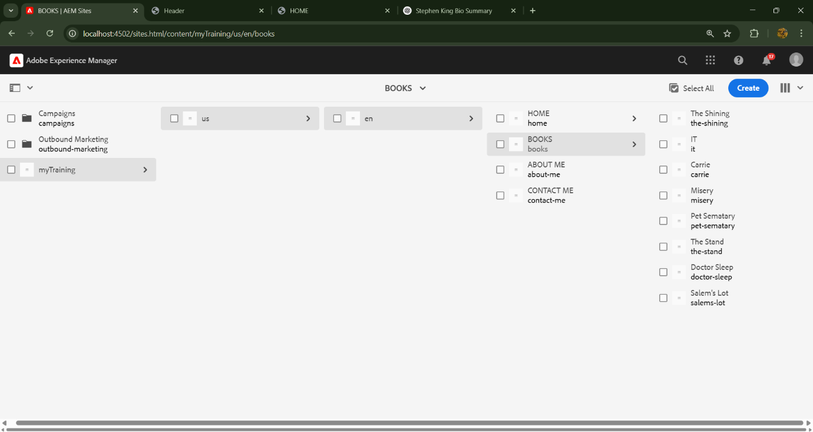

*LANDING PAGE*

The **main entry point** of the website, setting the tone for visitors with a dark, engaging layout inspired by Stephen King’s storytelling.

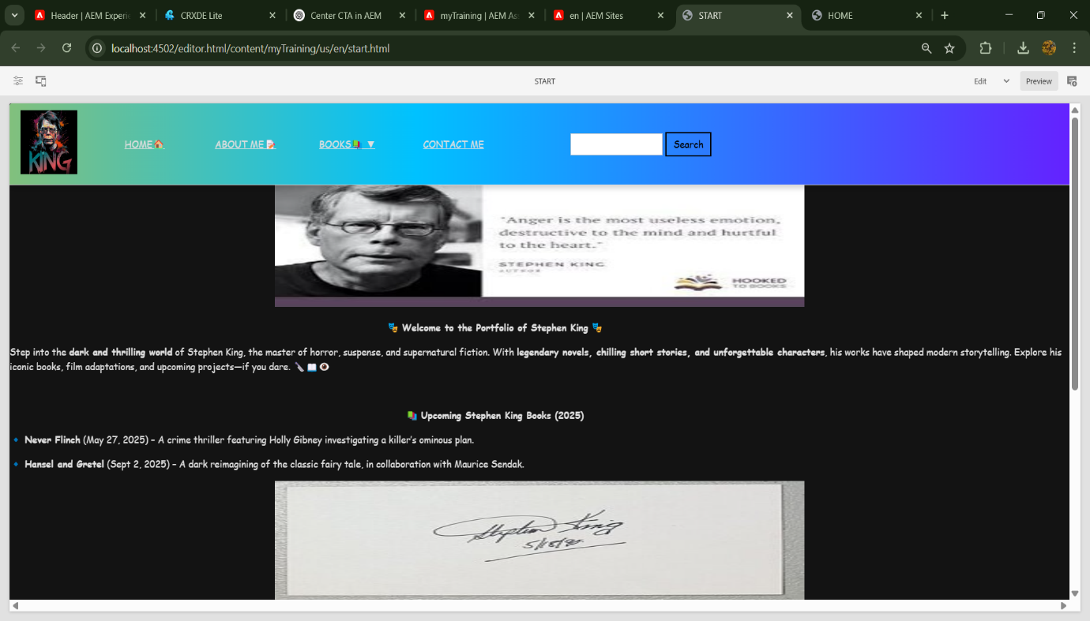

***HOME PAGE WITH AWARDS***

A **visually rich homepage** that introduces Stephen King’s awards and recognition he has received.

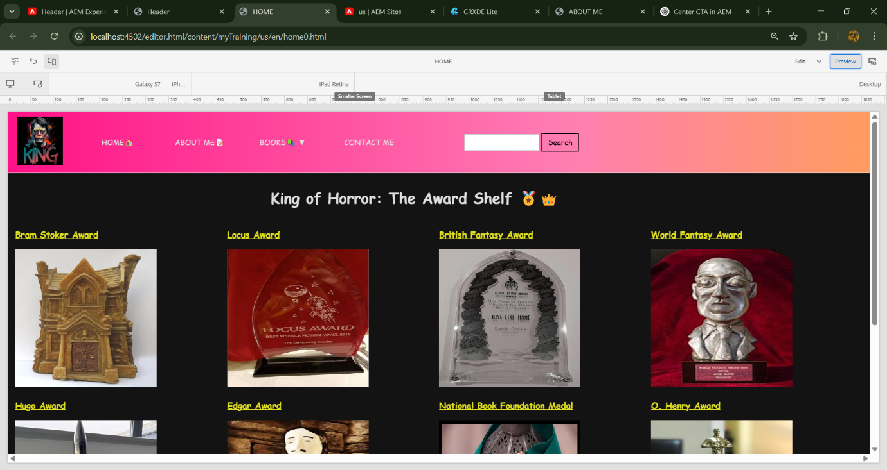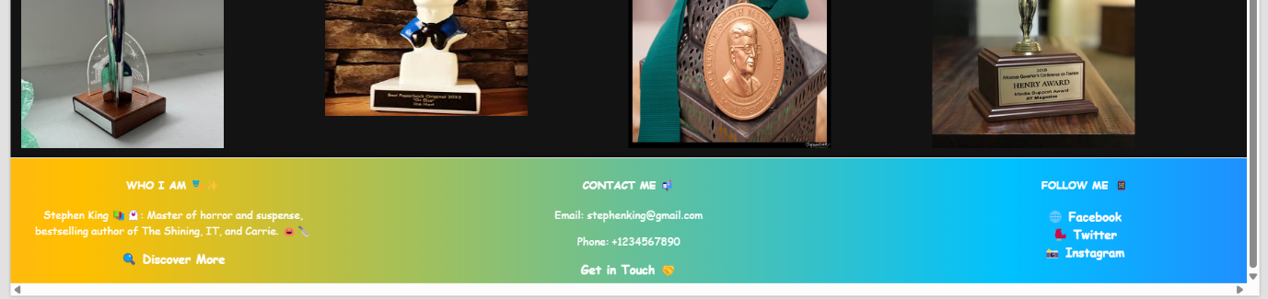

***Inside Award Page***

📜 Example 1 – A detailed award page with an image of the award, listing the books that received it and a description of the achievement.

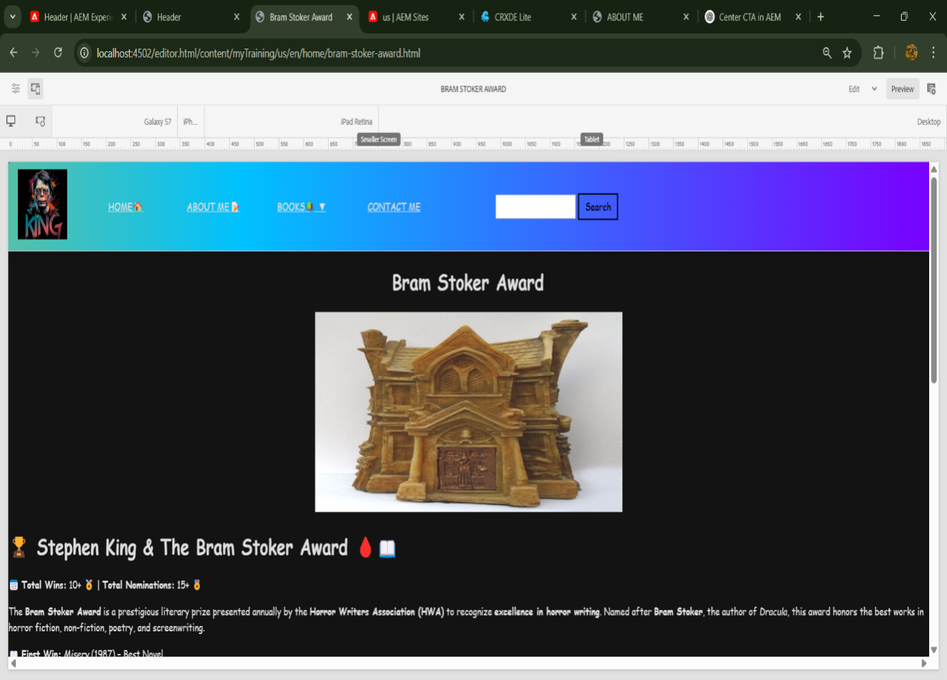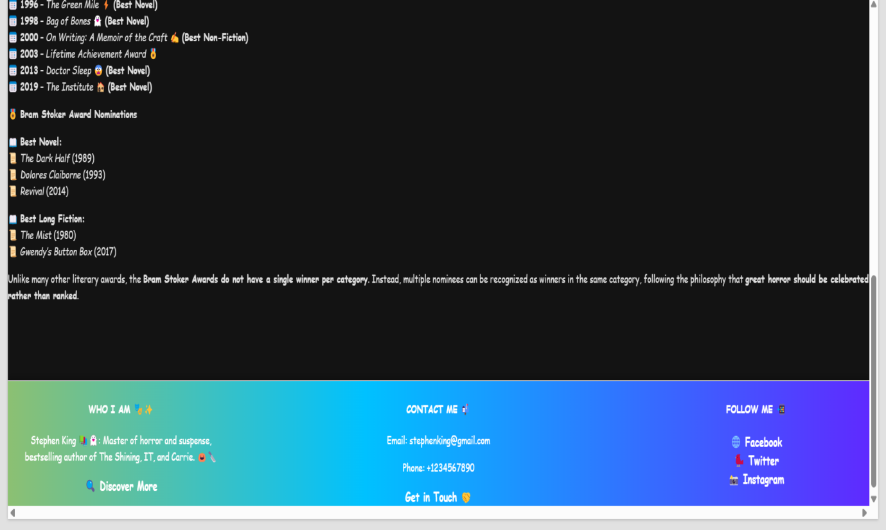

📜 Example 2

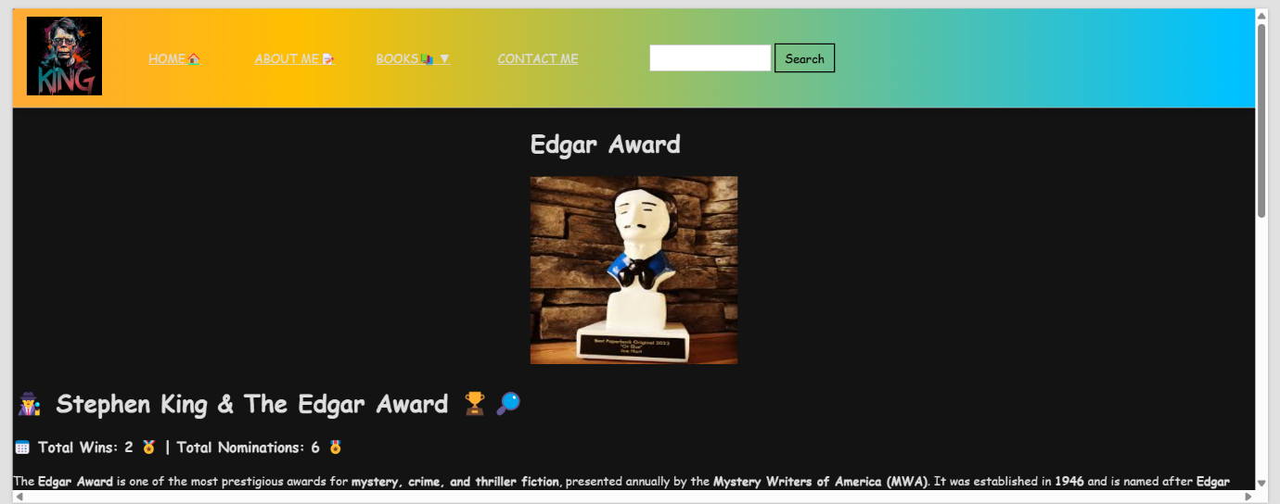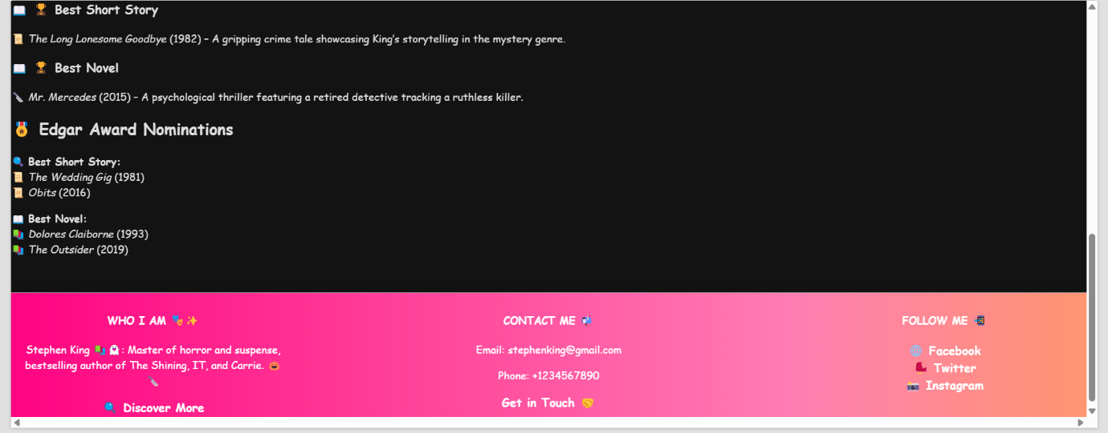

***ABOUT ME PAGE***

An informative section displaying Stephen King's biography, using an **author component** to dynamically showcase his details, achievements, and career highlights.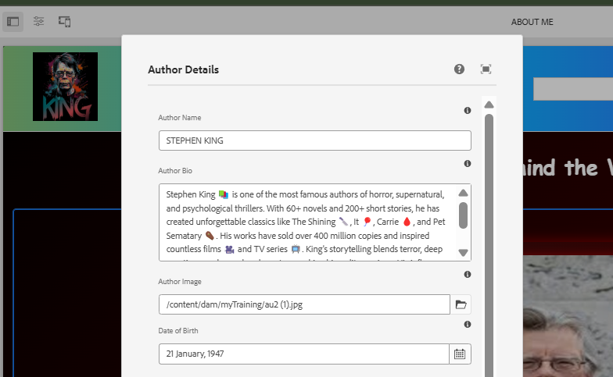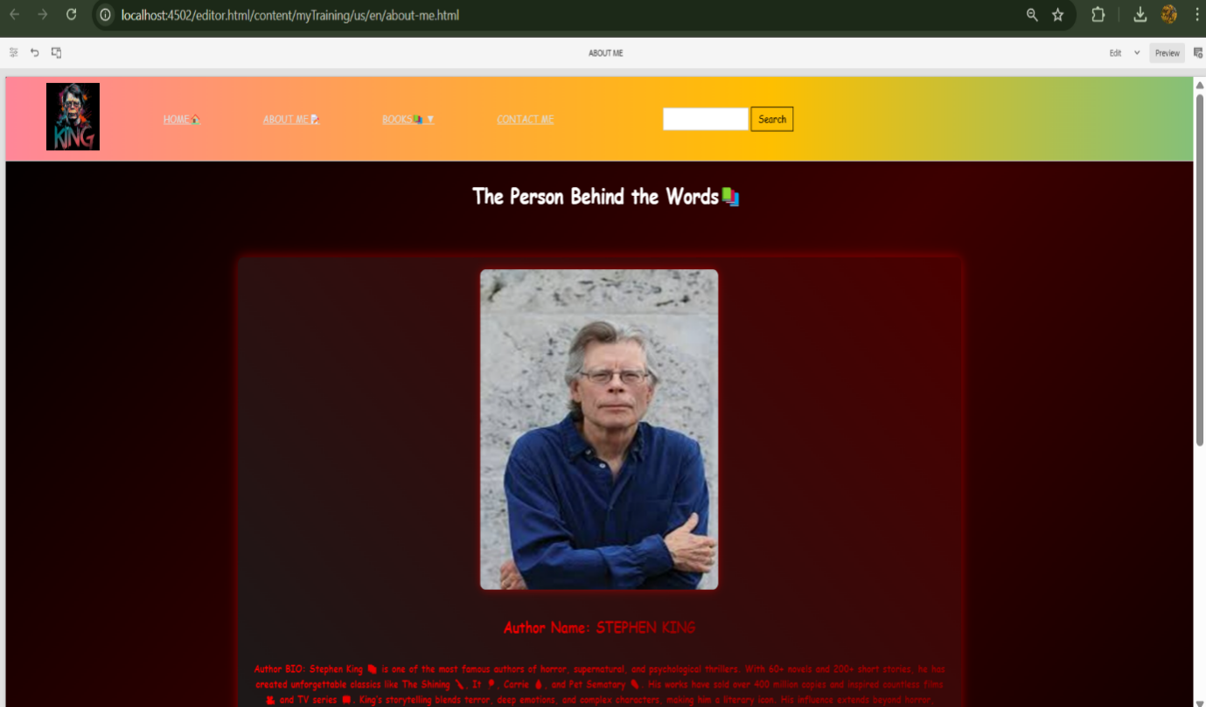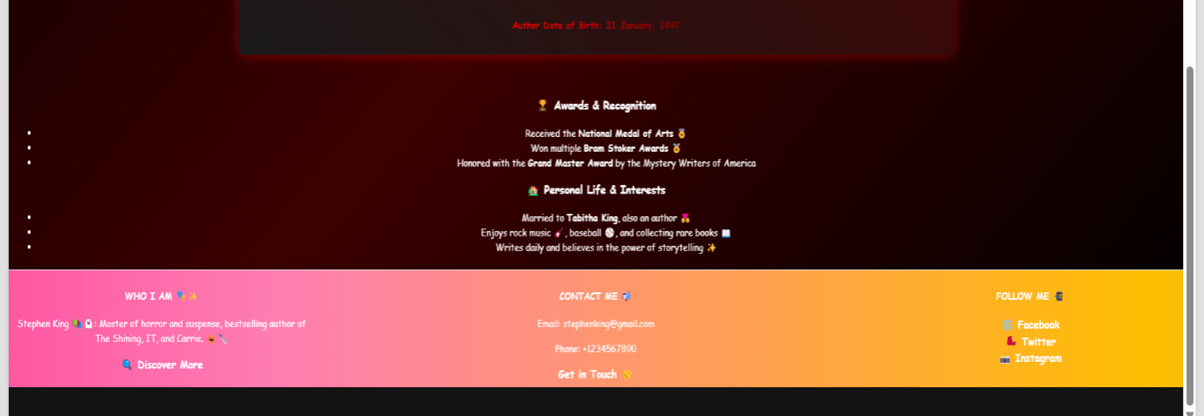

***BOOKS PAGES***

A dropdown menu listing Stephen King's books, allowing users to easily browse through his extensive bibliography.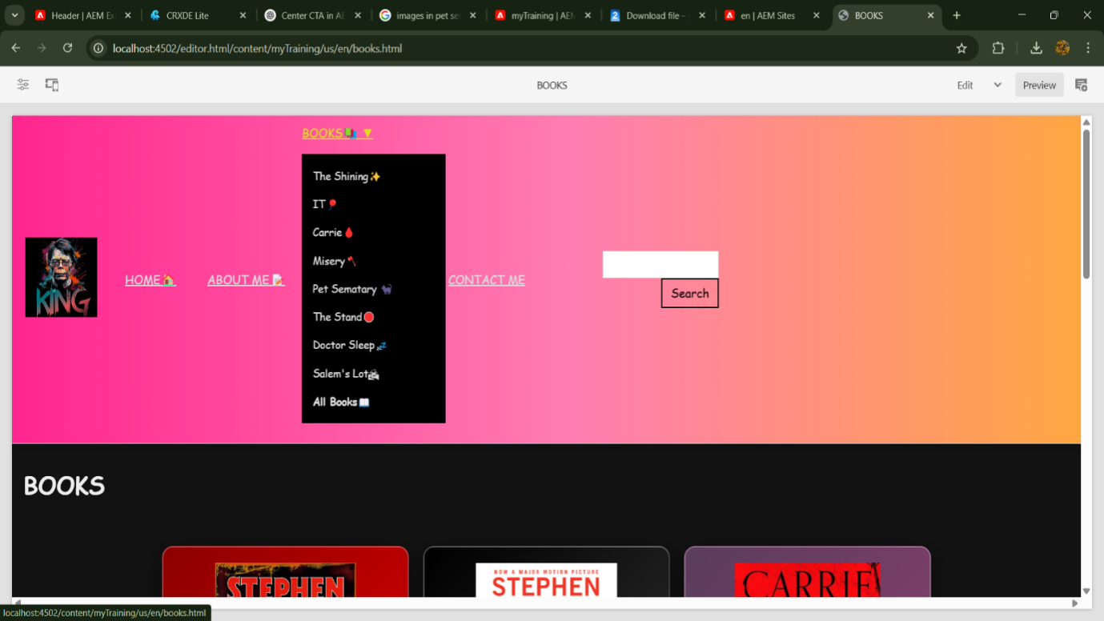

**AFTER CLICKING A BOOK IT REDIRECTS TO THAT BOOK PAGE**

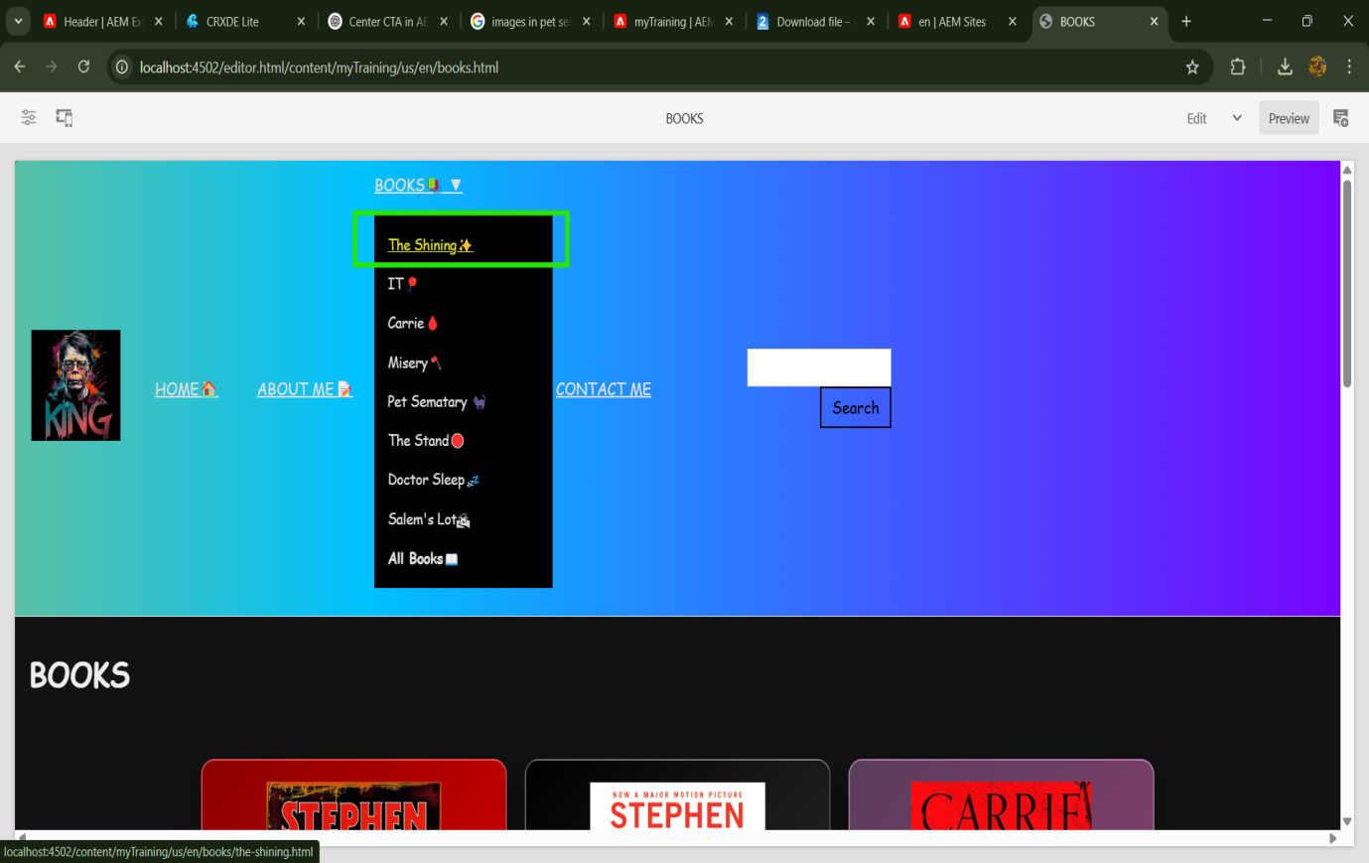

***Individual Book Page – Example 1***

📖 "The Shining" – A dedicated page offering detailed information on the novel, including its plot, themes, and cultural impact.

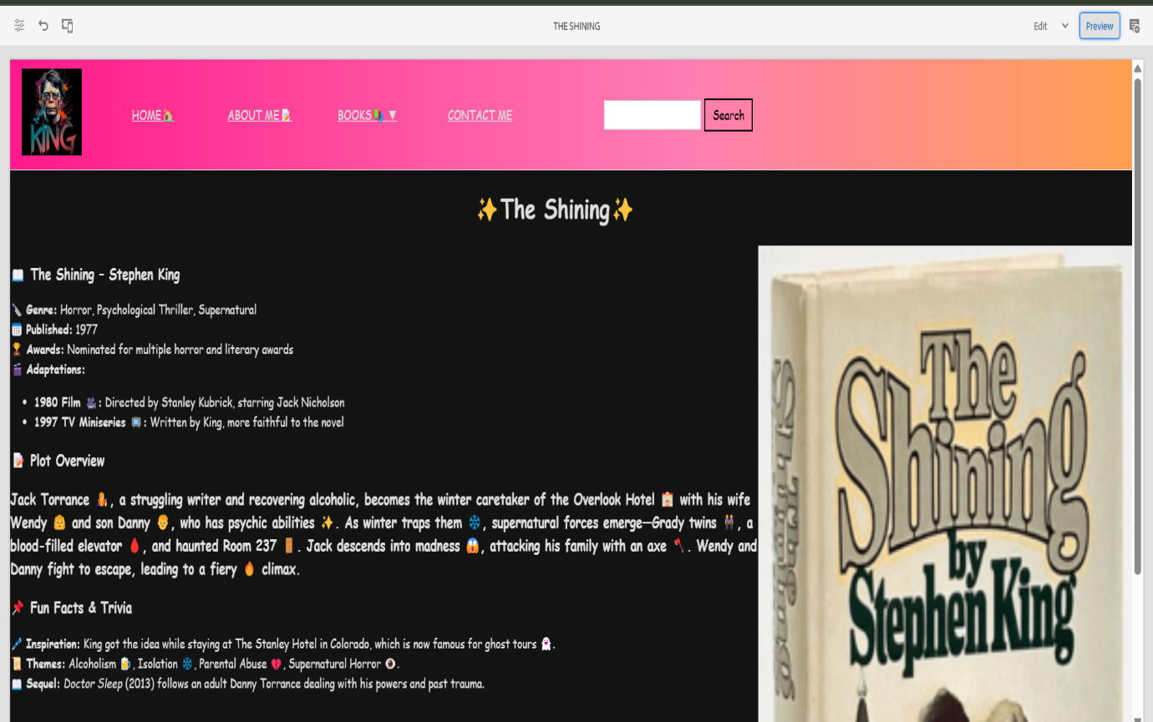

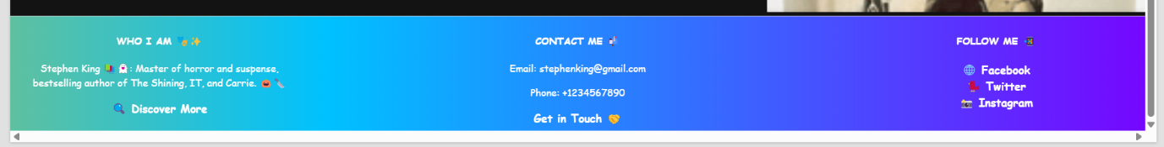

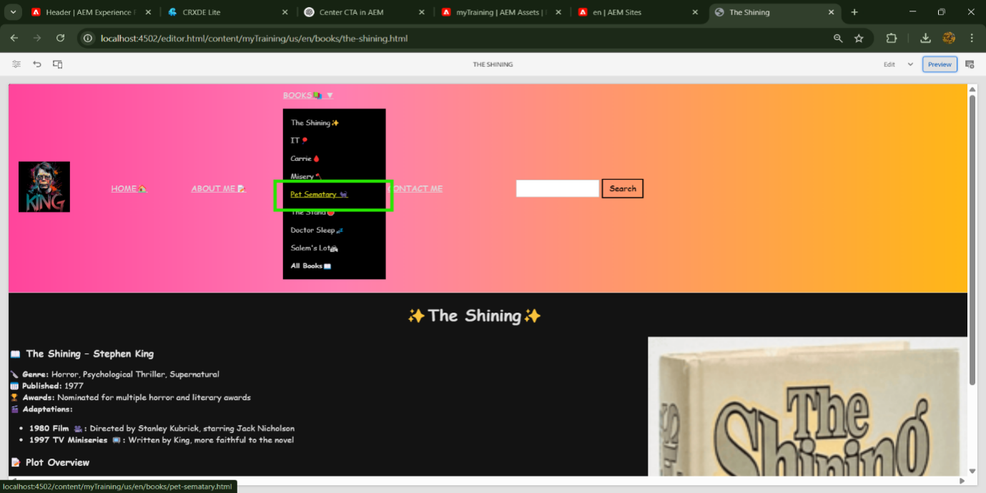

***Individual Book Page – Example 2***A second example of a book detail page, highlighting Stephen King’s storytelling and legacy in horror fiction.

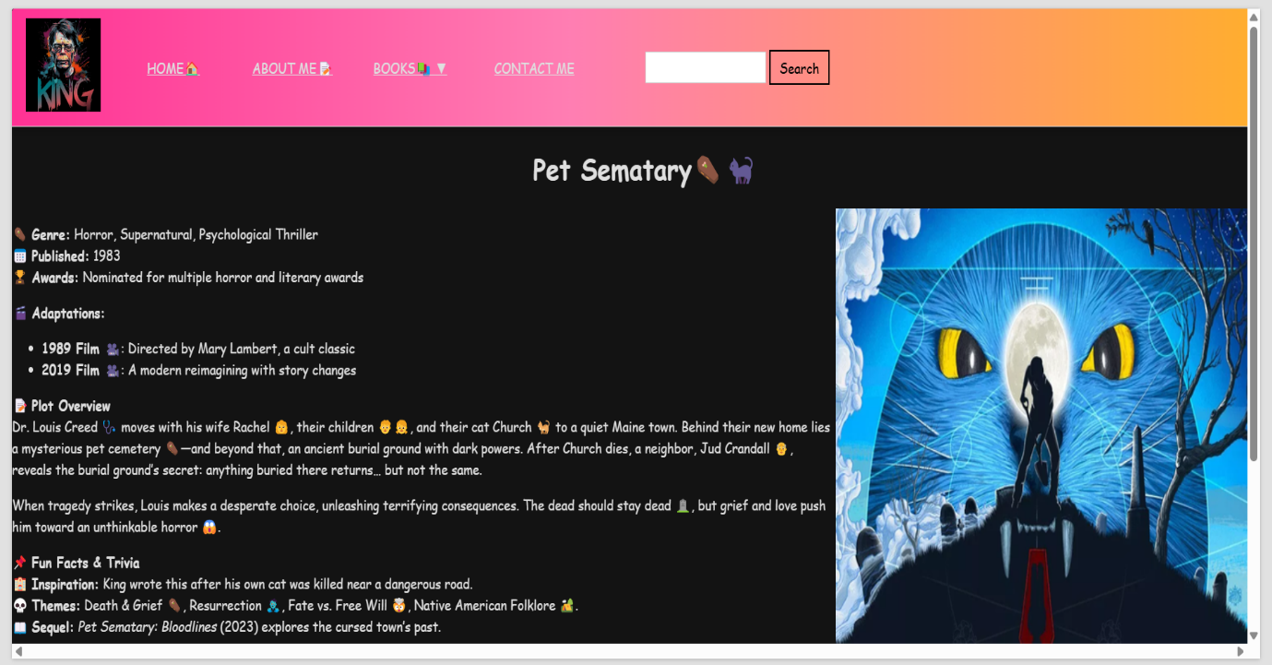

***BOOK PAGE WITH CARDS***

A modern, card-style layout that neatly arranges books in an interactive and visually engaging format**.**

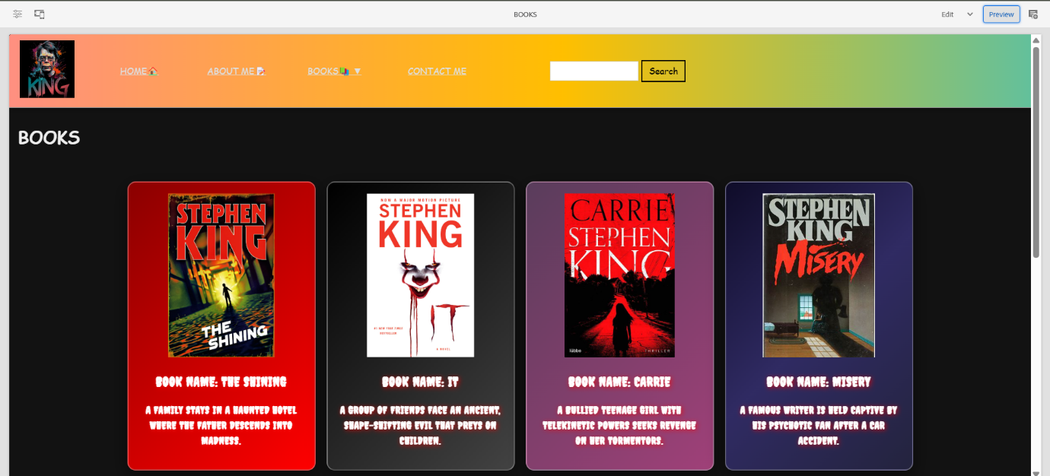

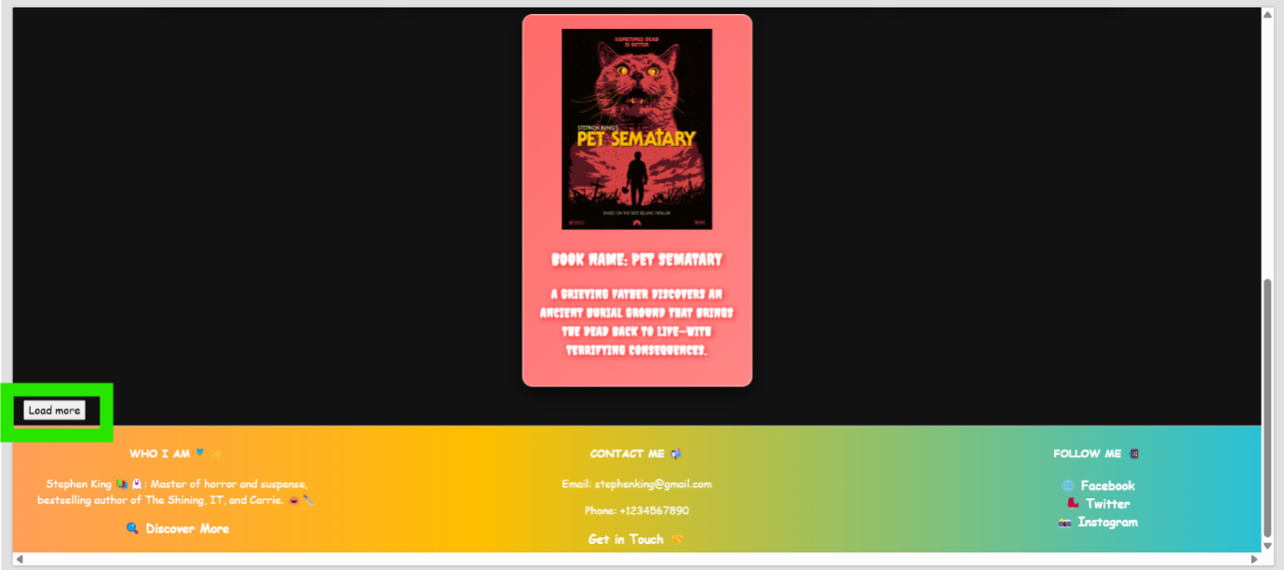

***LOAD MORE BUTTON***

A dynamic button that expands the book list, allowing users to explore more titles without reloading the page.

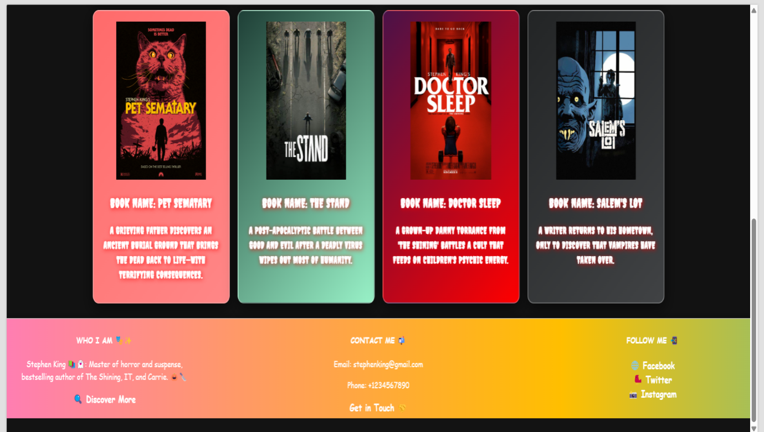

***CONTACT ME PAGE***

A dedicated contact section, allowing fans, readers, or collaborators to reach out directly for inquiries, discussions, or engagements**.**

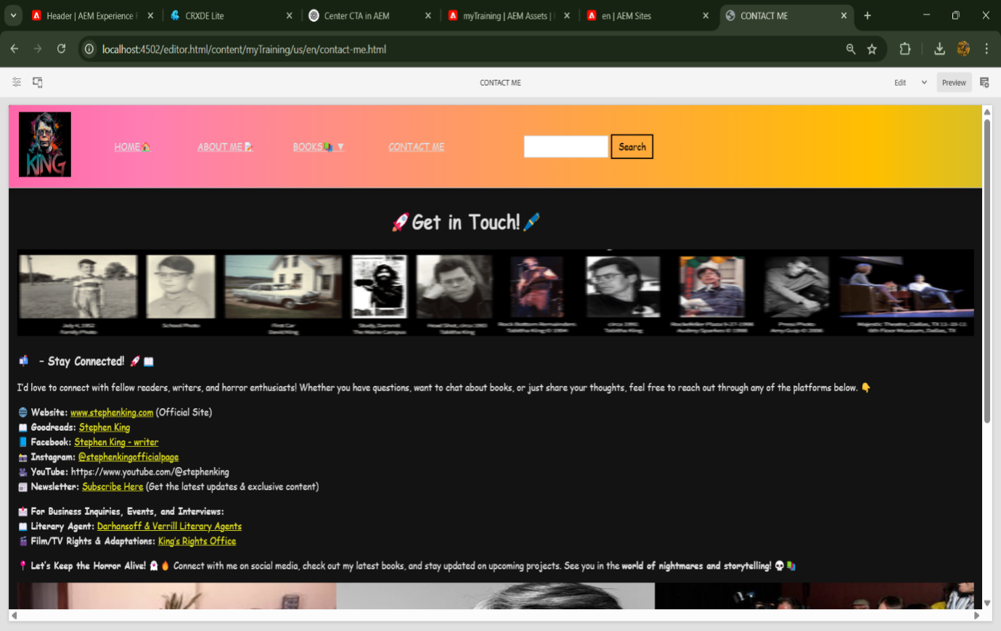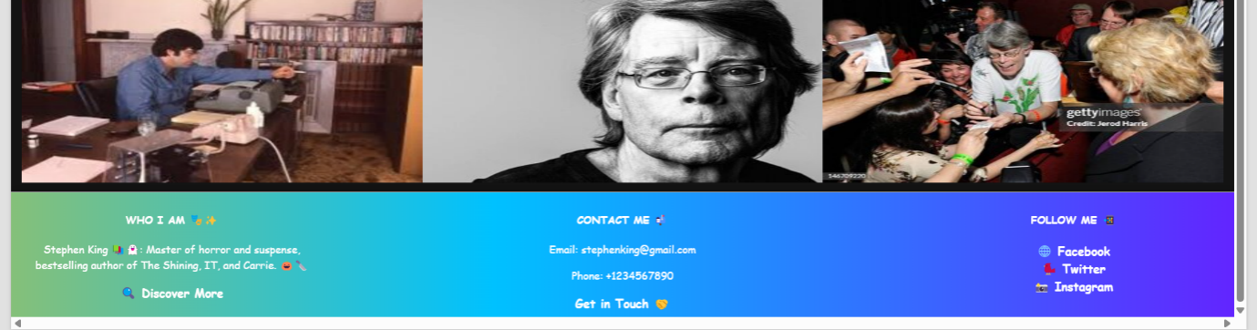

***Footer Navigation & Social Links***

A well-structured footer linking to key pages like "About Me" and "Contact Me," along with social media profiles for extended interaction.

